Test Case: tc001_SPX_Dev5_Crear_Requisicion_Spot_Tipo_Cobro_CC
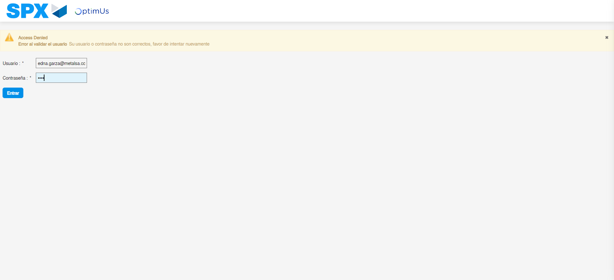Image file-name: QC_Testing-tc001_SPX_Dev5_Crear_Requisicion_Spot_Tipo_Cobro_CC-ene. 08 2024, 05 27 18 p. m.

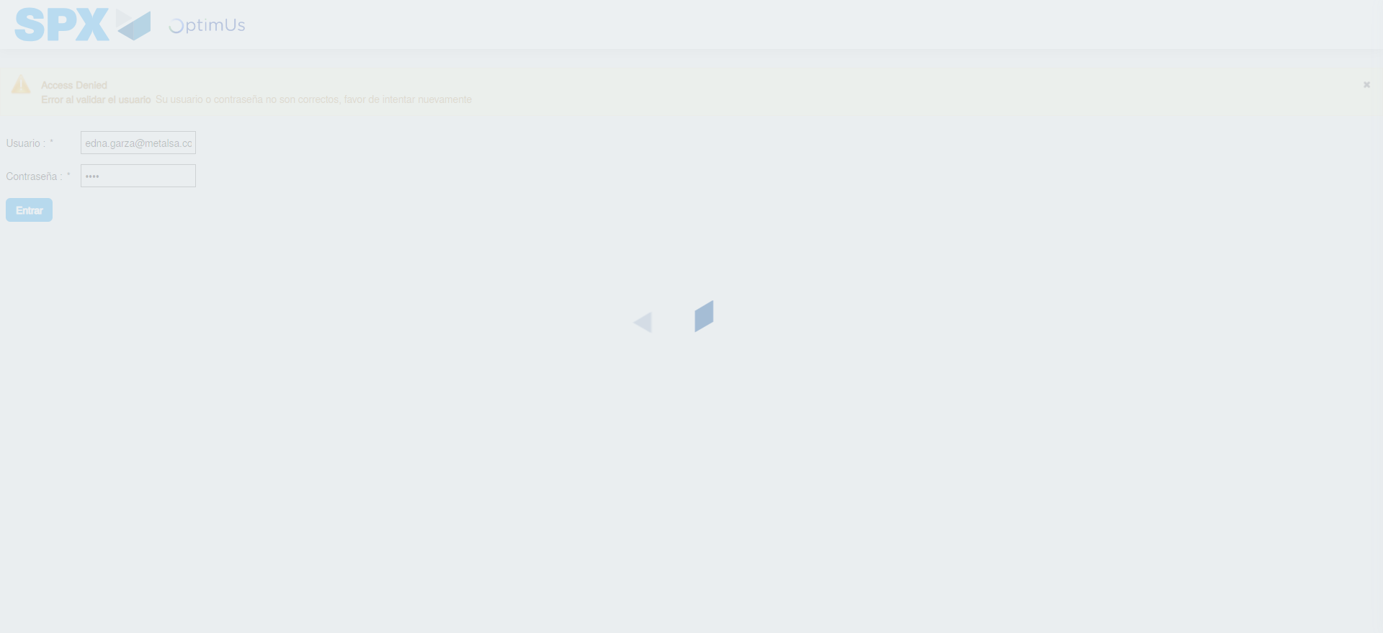Image file-name: QC_Testing-tc001_SPX_Dev5_Crear_Requisicion_Spot_Tipo_Cobro_CC-ene. 08 2024, 05 27 19 p. m.

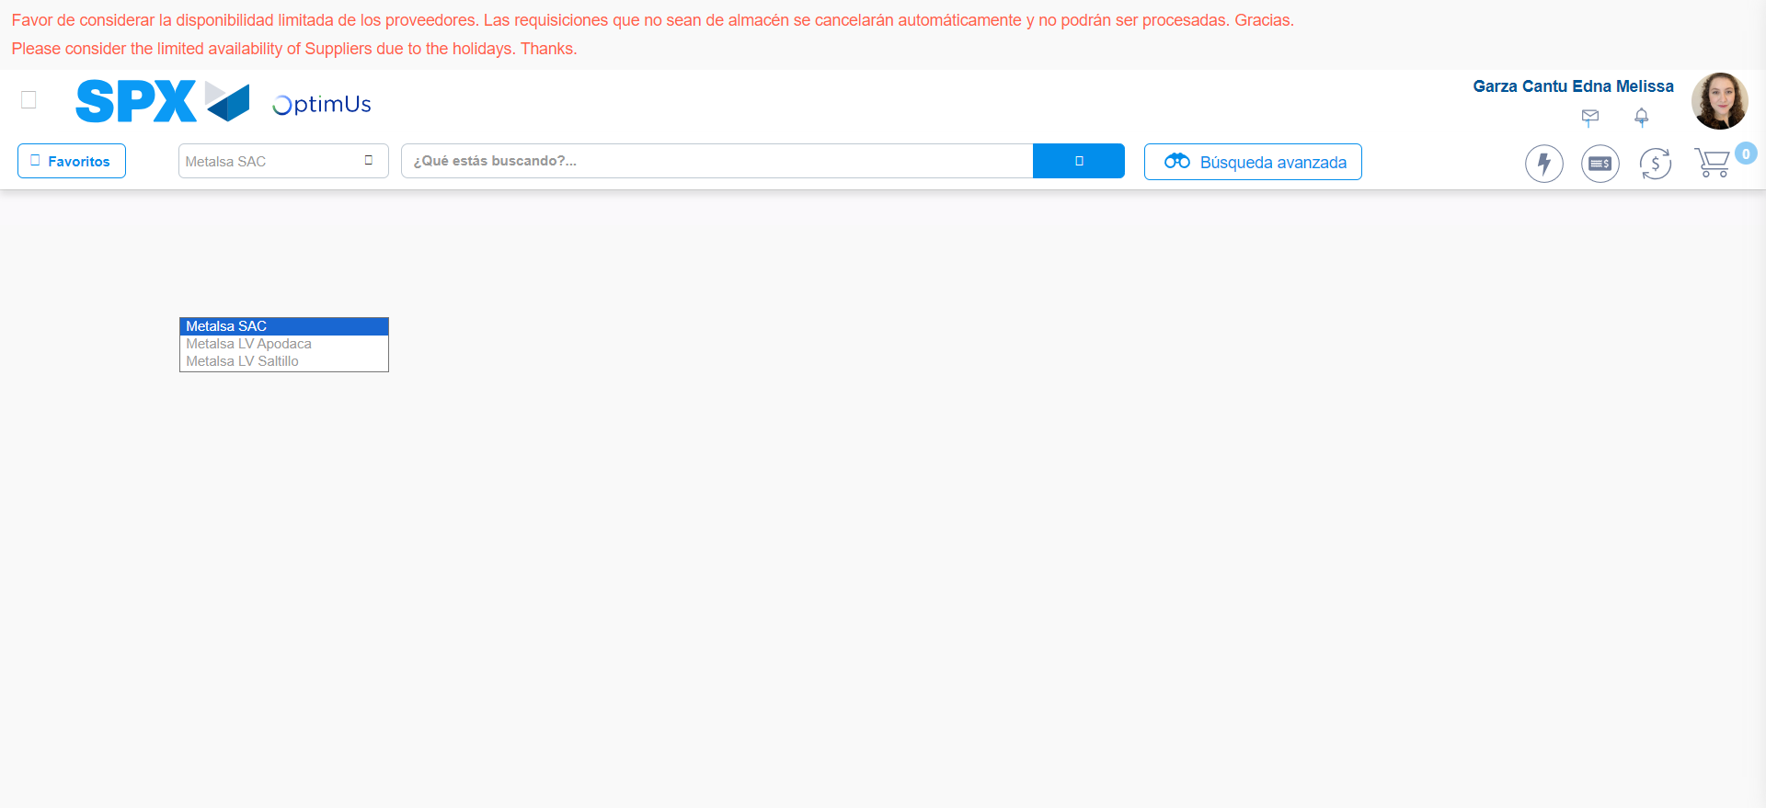Image file-name: QC_Testing-tc001_SPX_Dev5_Crear_Requisicion_Spot_Tipo_Cobro_CC-ene. 08 2024, 05 27 24 p. m.

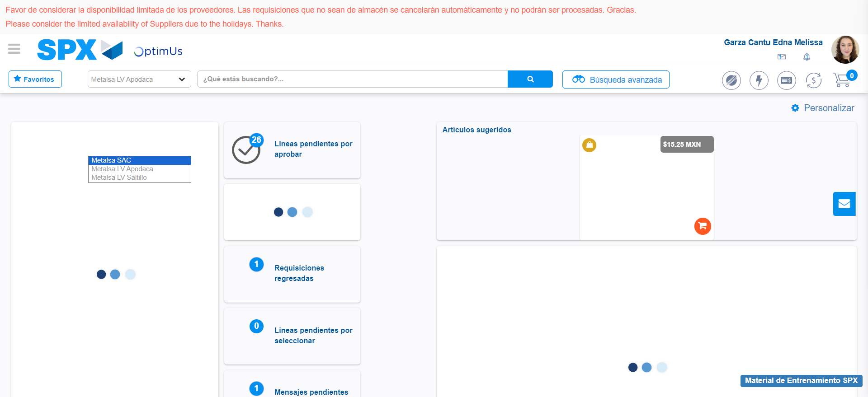Image file-name: QC_Testing-tc001_SPX_Dev5_Crear_Requisicion_Spot_Tipo_Cobro_CC-ene. 08 2024, 05 27 25 p. m.

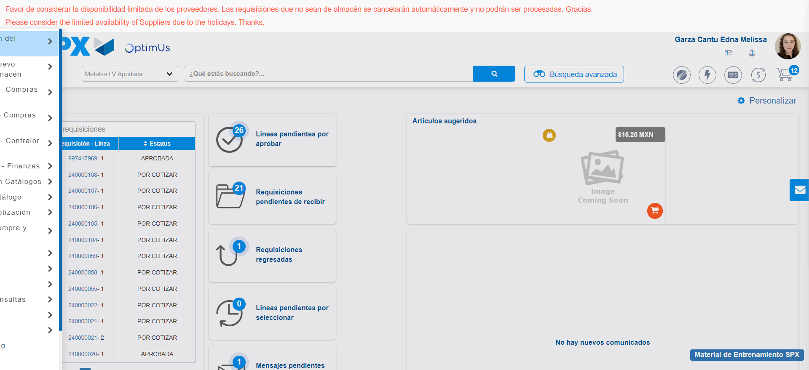Image file-name: QC_Testing-tc001_SPX_Dev5_Crear_Requisicion_Spot_Tipo_Cobro_CC-ene. 08 2024, 05 27 26 p. m.

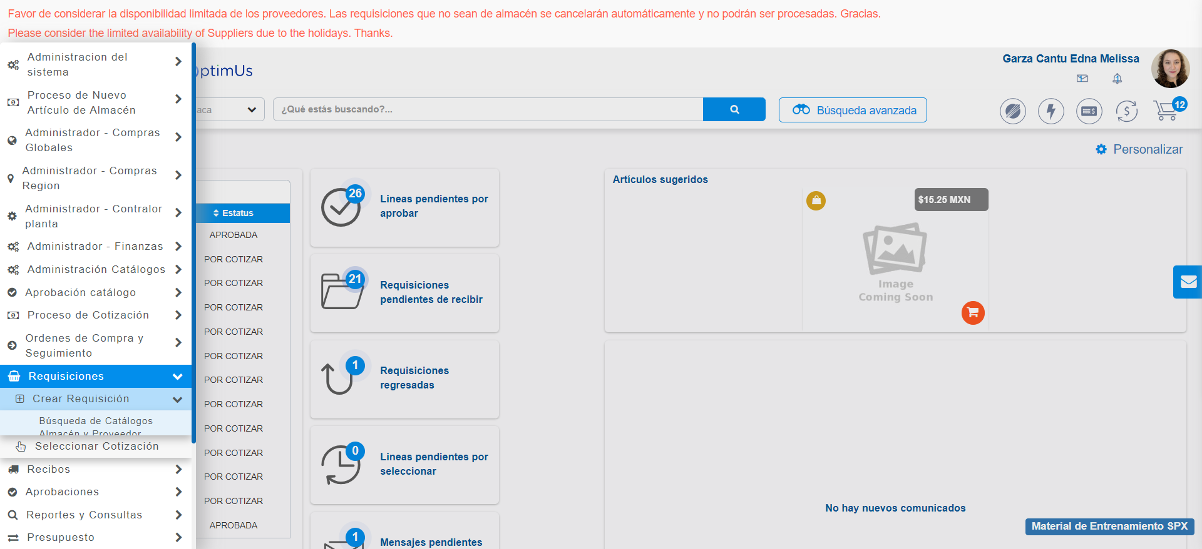Image file-name: QC_Testing-tc001_SPX_Dev5_Crear_Requisicion_Spot_Tipo_Cobro_CC-ene. 08 2024, 05 27 27 p. m.

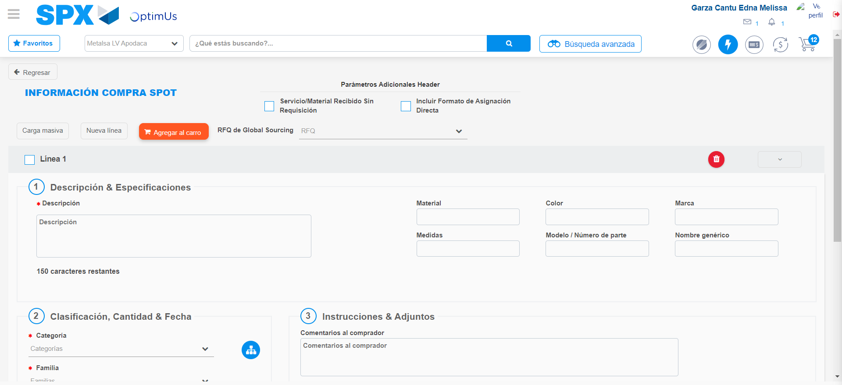Image file-name: QC_Testing-tc001_SPX_Dev5_Crear_Requisicion_Spot_Tipo_Cobro_CC-ene. 08 2024, 05 27 31 p. m.

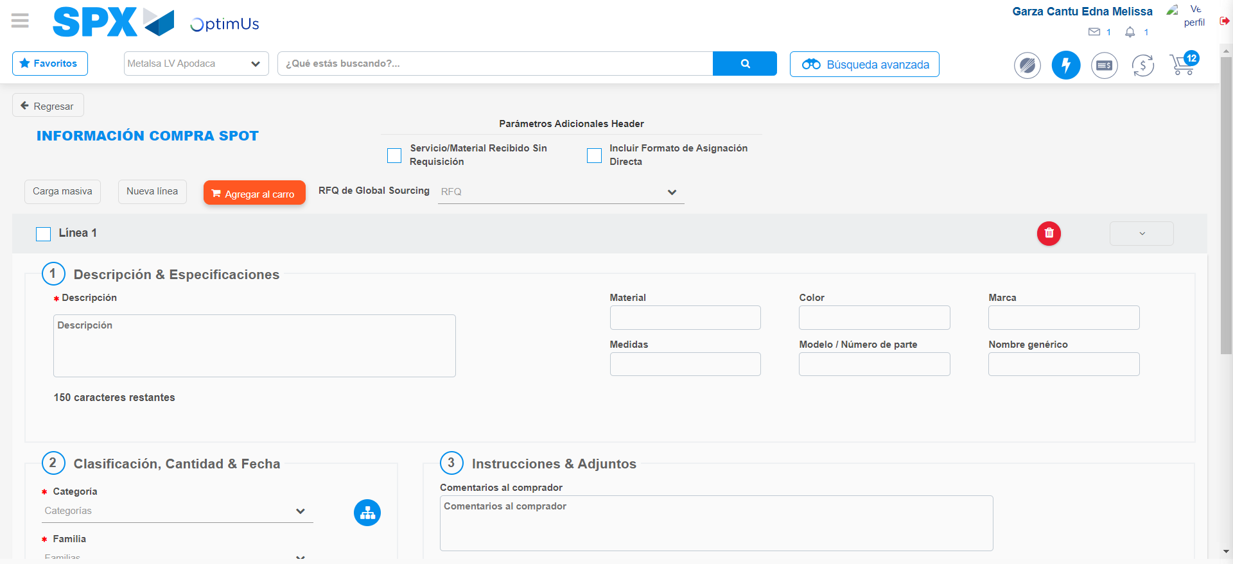Image file-name: QC_Testing-tc001_SPX_Dev5_Crear_Requisicion_Spot_Tipo_Cobro_CC-ene. 08 2024, 05 27 32 p. m.

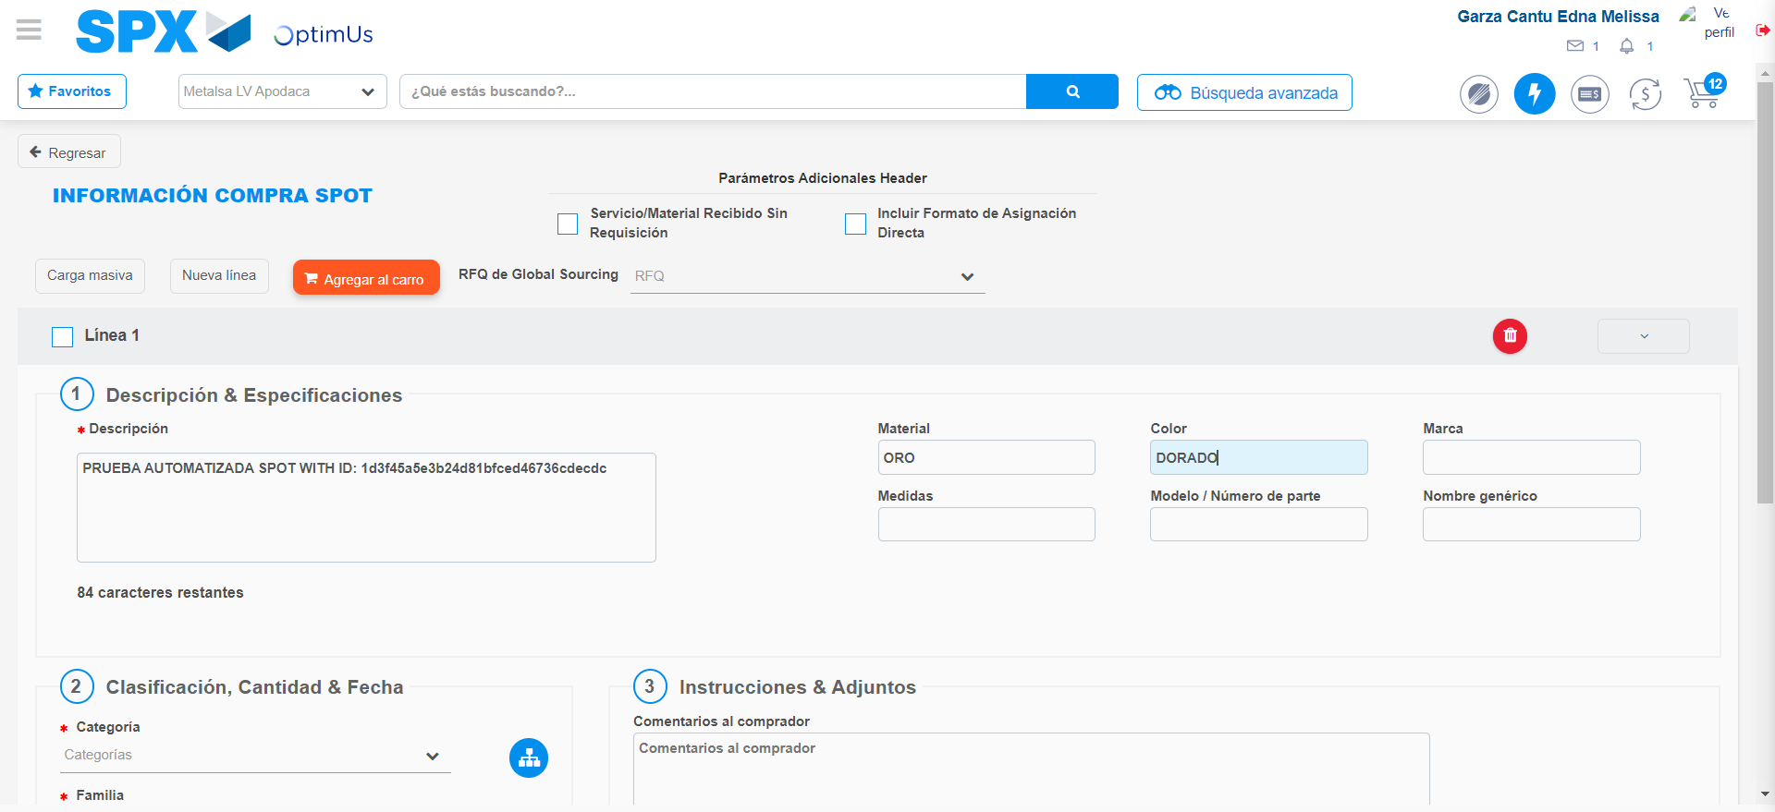Image file-name: QC_Testing-tc001_SPX_Dev5_Crear_Requisicion_Spot_Tipo_Cobro_CC-ene. 08 2024, 05 27 33 p. m.

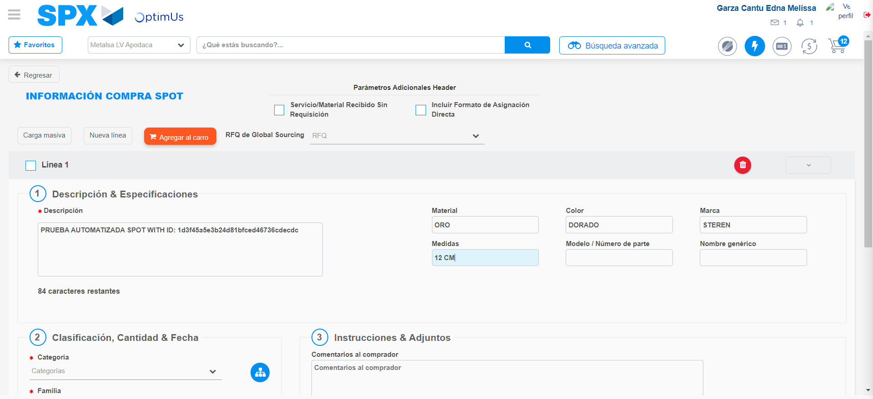Image file-name: QC_Testing-tc001_SPX_Dev5_Crear_Requisicion_Spot_Tipo_Cobro_CC-ene. 08 2024, 05 27 34 p. m.

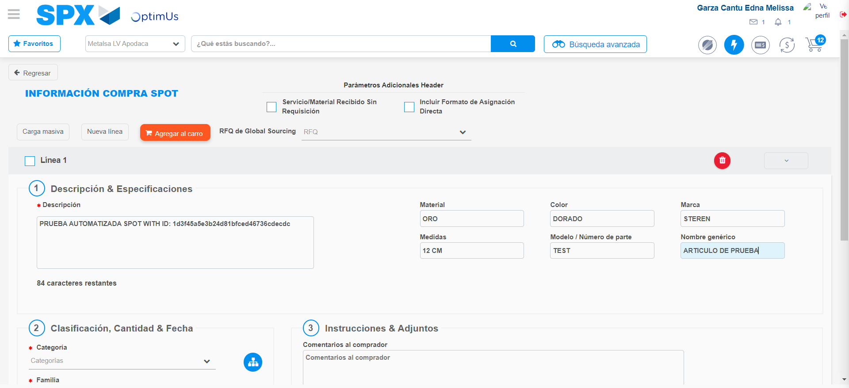Image file-name: QC_Testing-tc001_SPX_Dev5_Crear_Requisicion_Spot_Tipo_Cobro_CC-ene. 08 2024, 05 27 35 p. m.

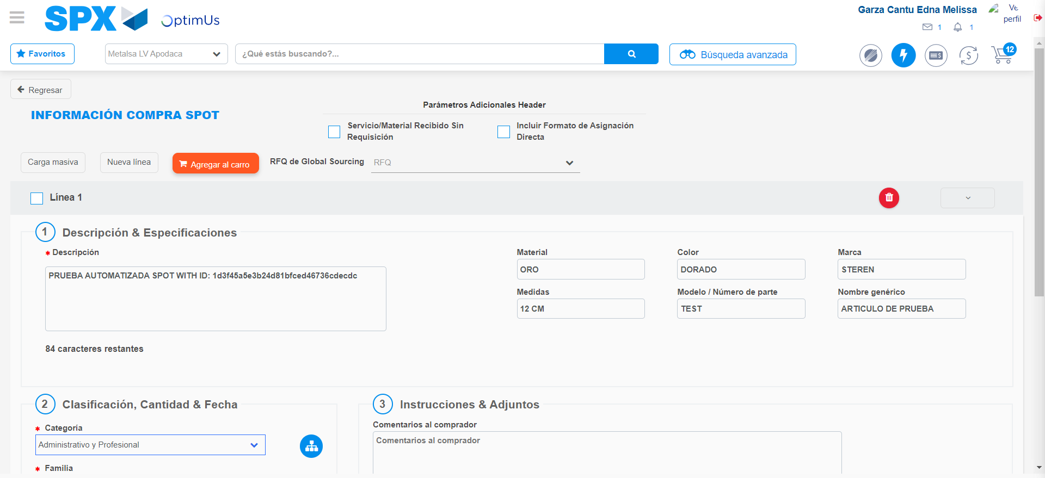Image file-name: QC_Testing-tc001_SPX_Dev5_Crear_Requisicion_Spot_Tipo_Cobro_CC-ene. 08 2024, 05 27 36 p. m.

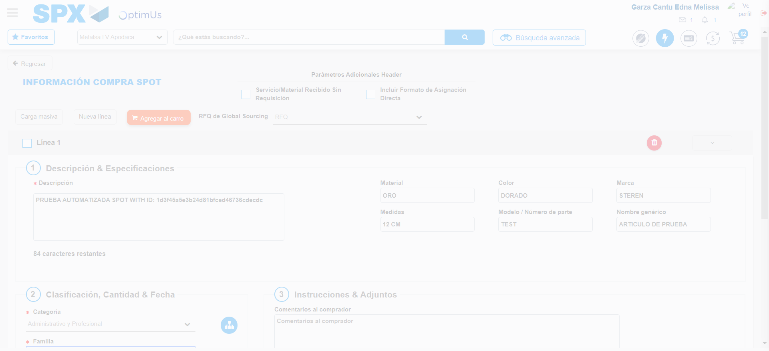Image file-name: QC_Testing-tc001_SPX_Dev5_Crear_Requisicion_Spot_Tipo_Cobro_CC-ene. 08 2024, 05 27 40 p. m.

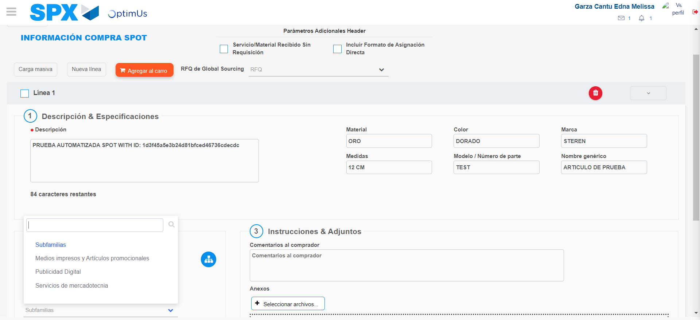Image file-name: QC_Testing-tc001_SPX_Dev5_Crear_Requisicion_Spot_Tipo_Cobro_CC-ene. 08 2024, 05 27 44 p. m.

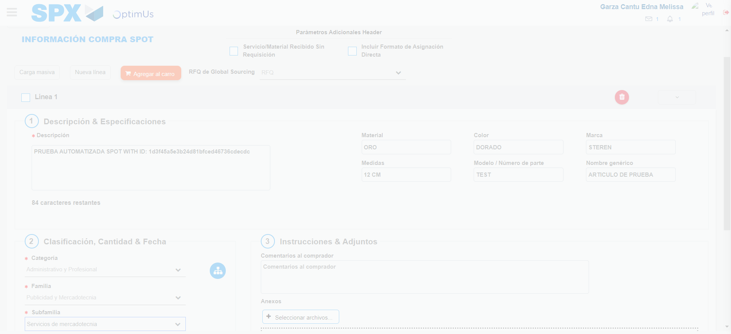Image file-name: QC_Testing-tc001_SPX_Dev5_Crear_Requisicion_Spot_Tipo_Cobro_CC-ene. 08 2024, 05 27 45 p. m.

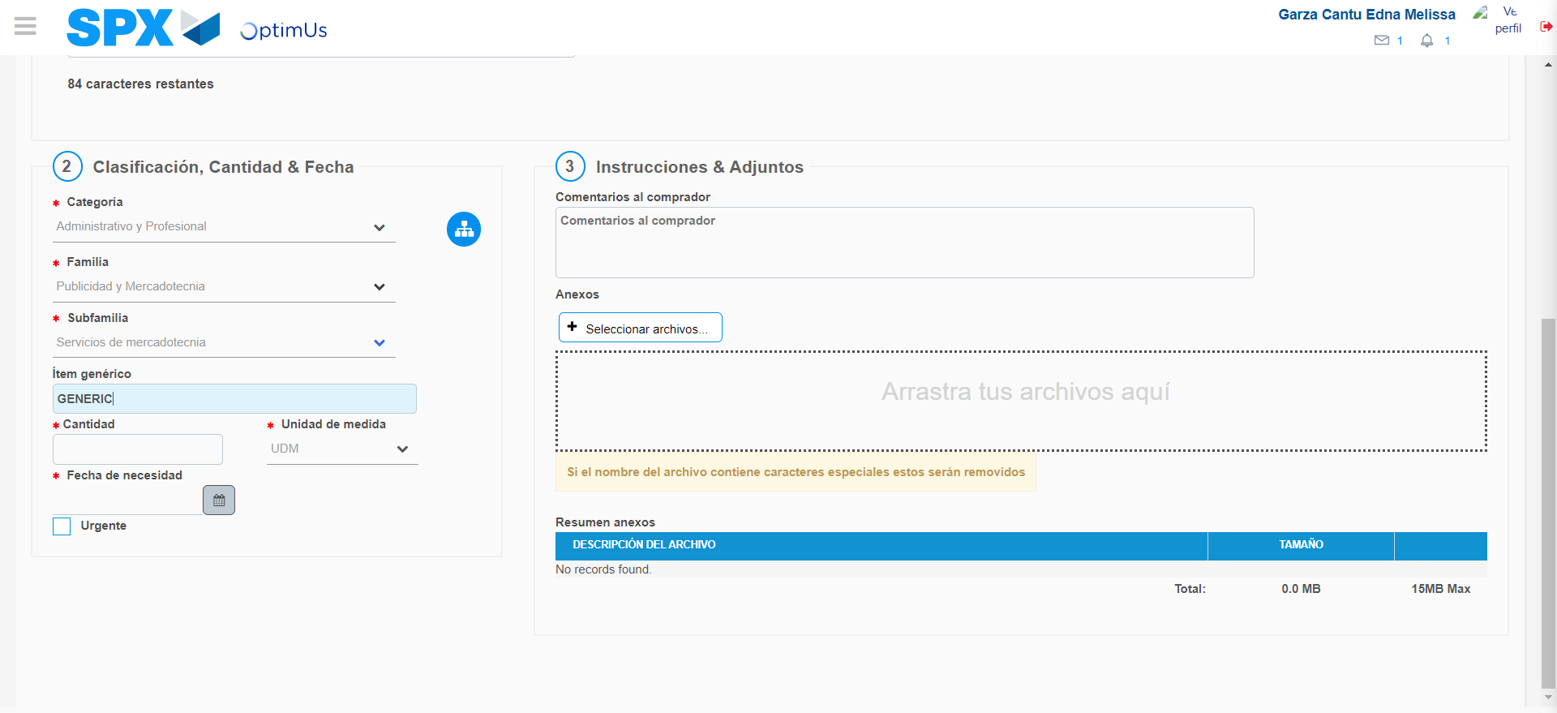Image file-name: QC_Testing-tc001_SPX_Dev5_Crear_Requisicion_Spot_Tipo_Cobro_CC-ene. 08 2024, 05 27 48 p. m.

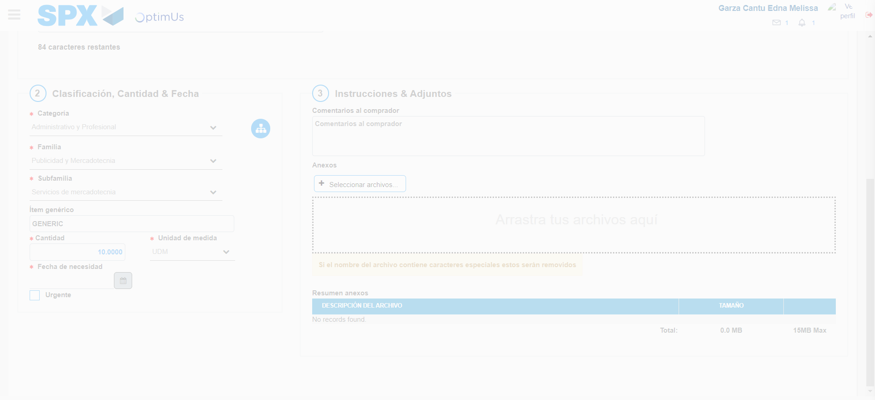Image file-name: QC_Testing-tc001_SPX_Dev5_Crear_Requisicion_Spot_Tipo_Cobro_CC-ene. 08 2024, 05 27 49 p. m.

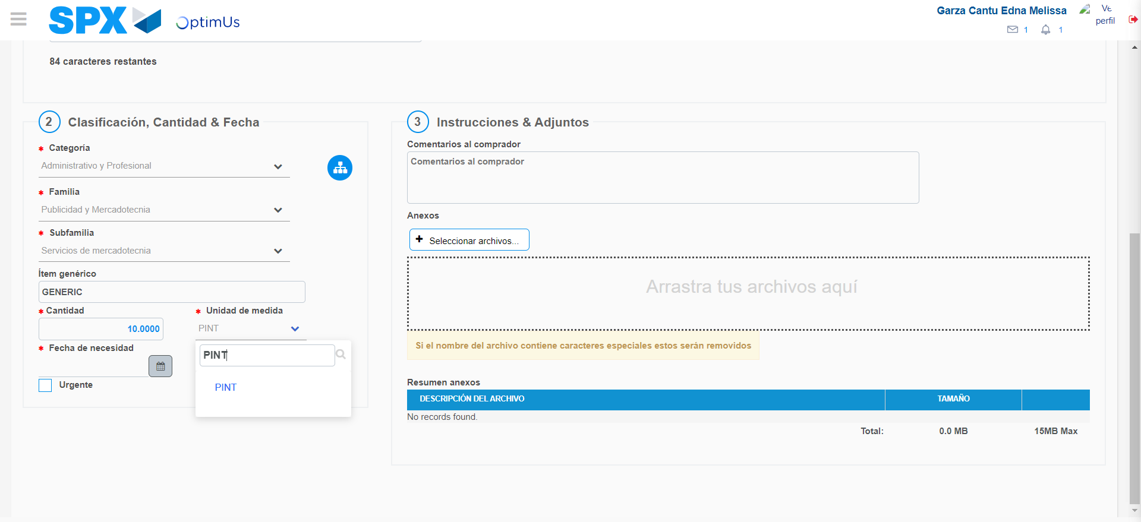Image file-name: QC_Testing-tc001_SPX_Dev5_Crear_Requisicion_Spot_Tipo_Cobro_CC-ene. 08 2024, 05 27 50 p. m.

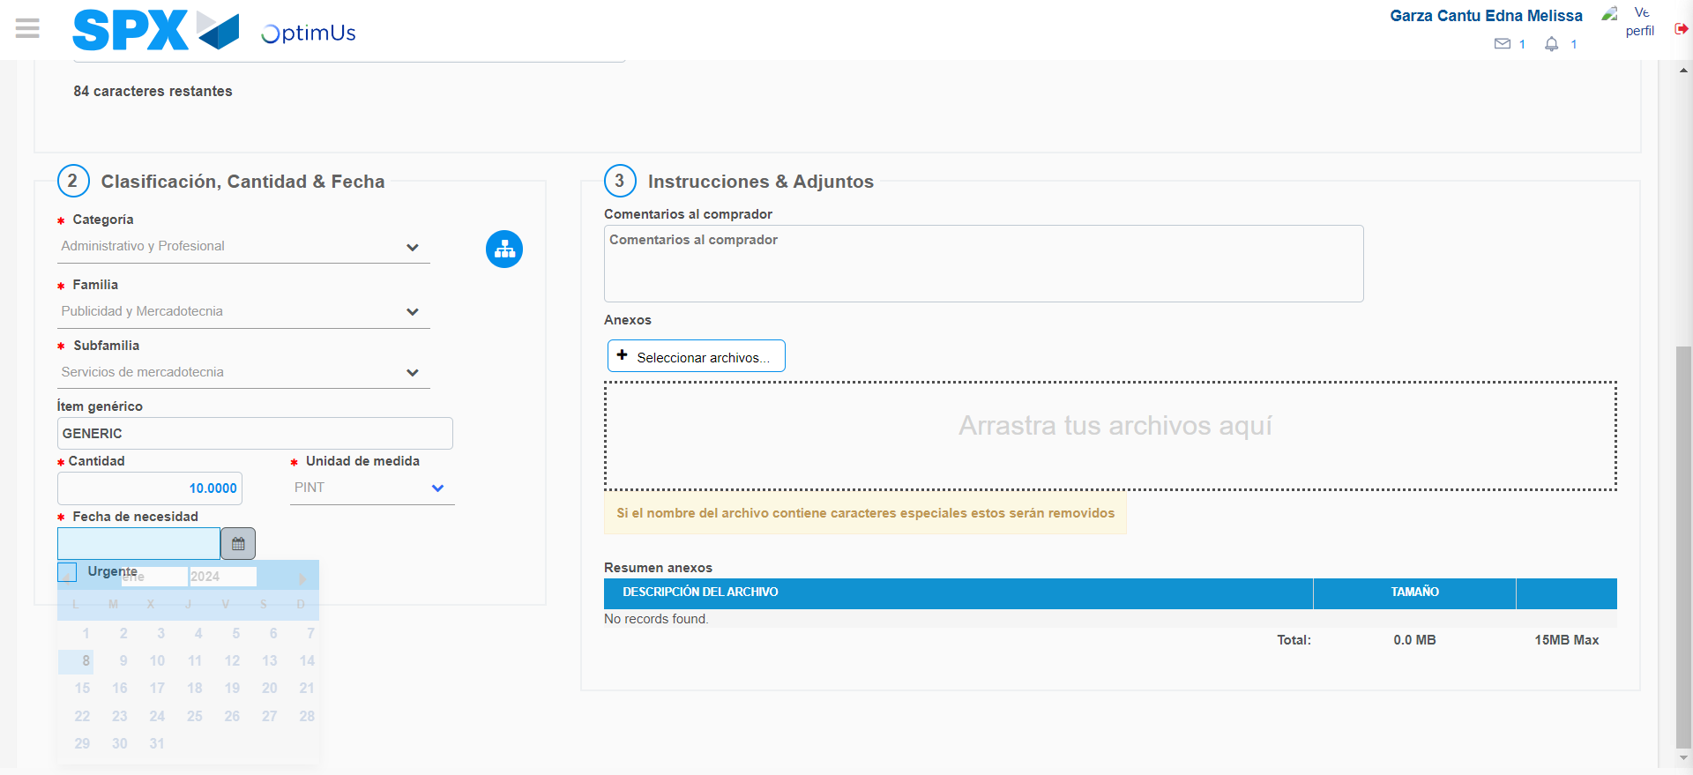Image file-name: QC_Testing-tc001_SPX_Dev5_Crear_Requisicion_Spot_Tipo_Cobro_CC-ene. 08 2024, 05 27 51 p. m.

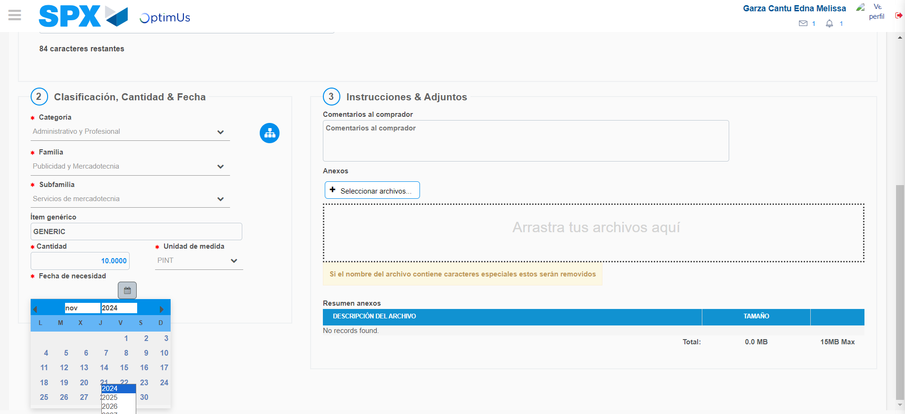Image file-name: QC_Testing-tc001_SPX_Dev5_Crear_Requisicion_Spot_Tipo_Cobro_CC-ene. 08 2024, 05 27 52 p. m.

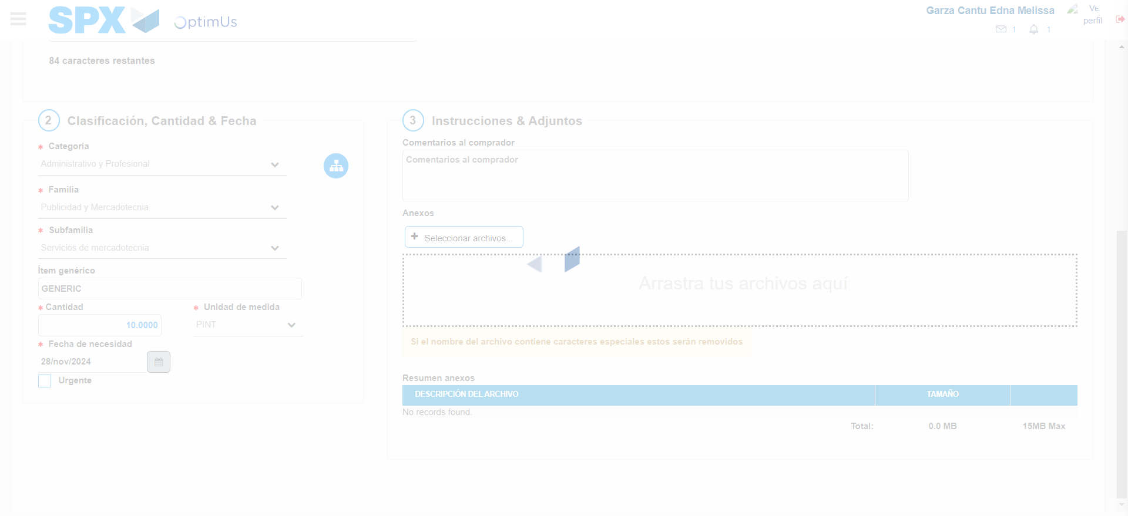Image file-name: QC_Testing-tc001_SPX_Dev5_Crear_Requisicion_Spot_Tipo_Cobro_CC-ene. 08 2024, 05 28 03 p. m.

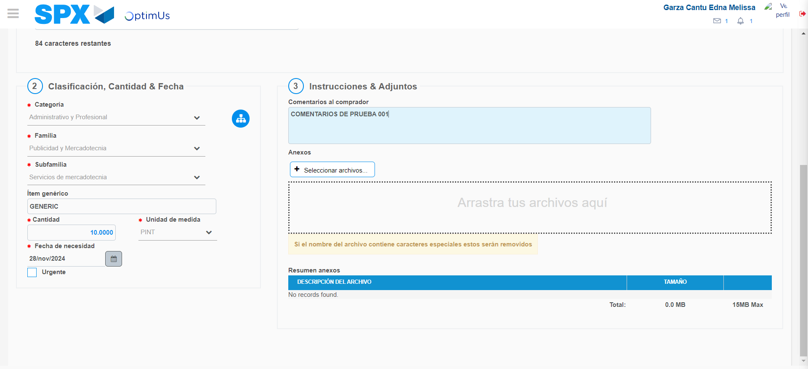Image file-name: QC_Testing-tc001_SPX_Dev5_Crear_Requisicion_Spot_Tipo_Cobro_CC-ene. 08 2024, 05 28 04 p. m.

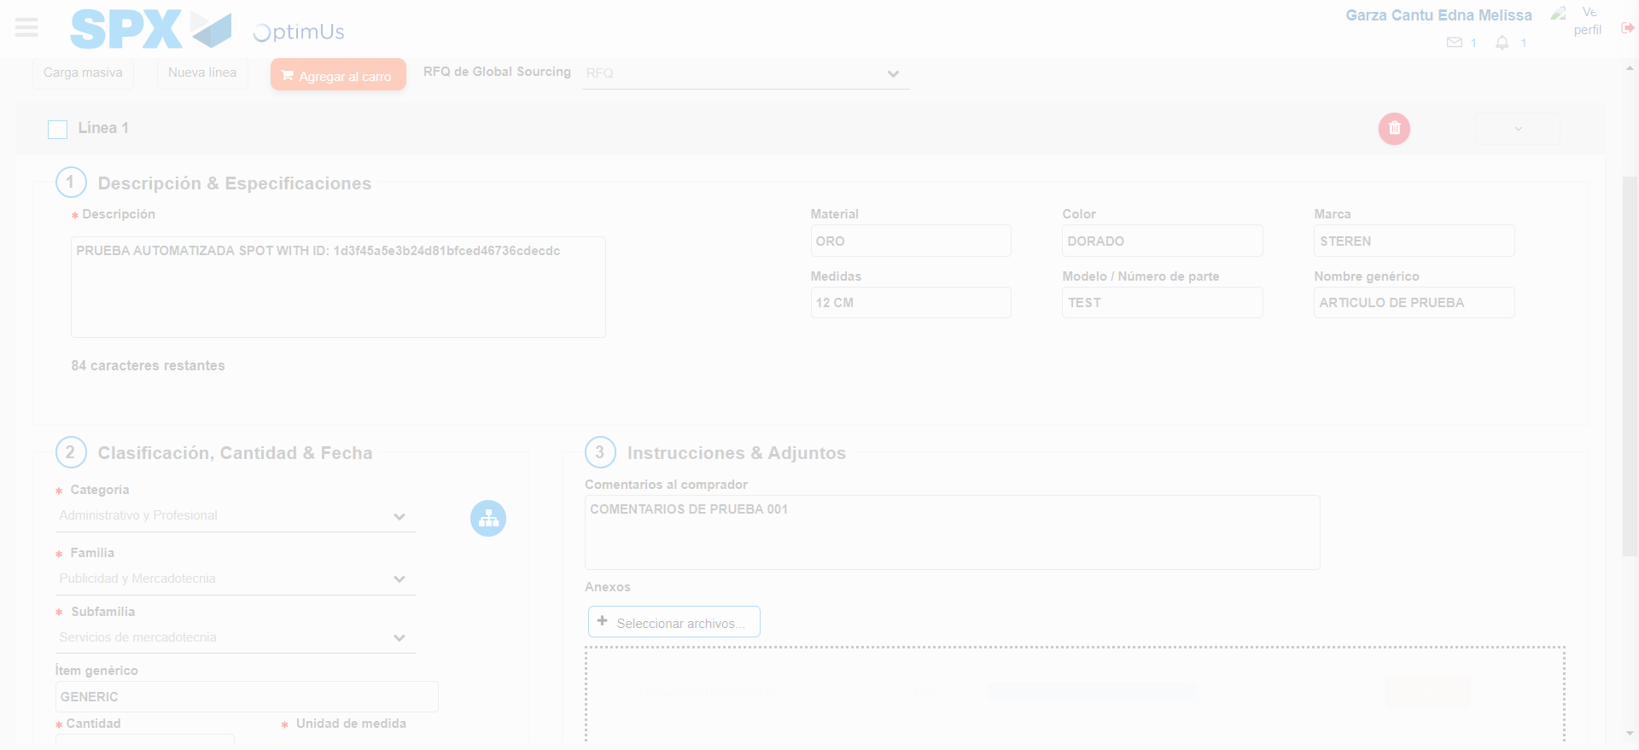Image file-name: QC_Testing-tc001_SPX_Dev5_Crear_Requisicion_Spot_Tipo_Cobro_CC-ene. 08 2024, 05 28 05 p. m.

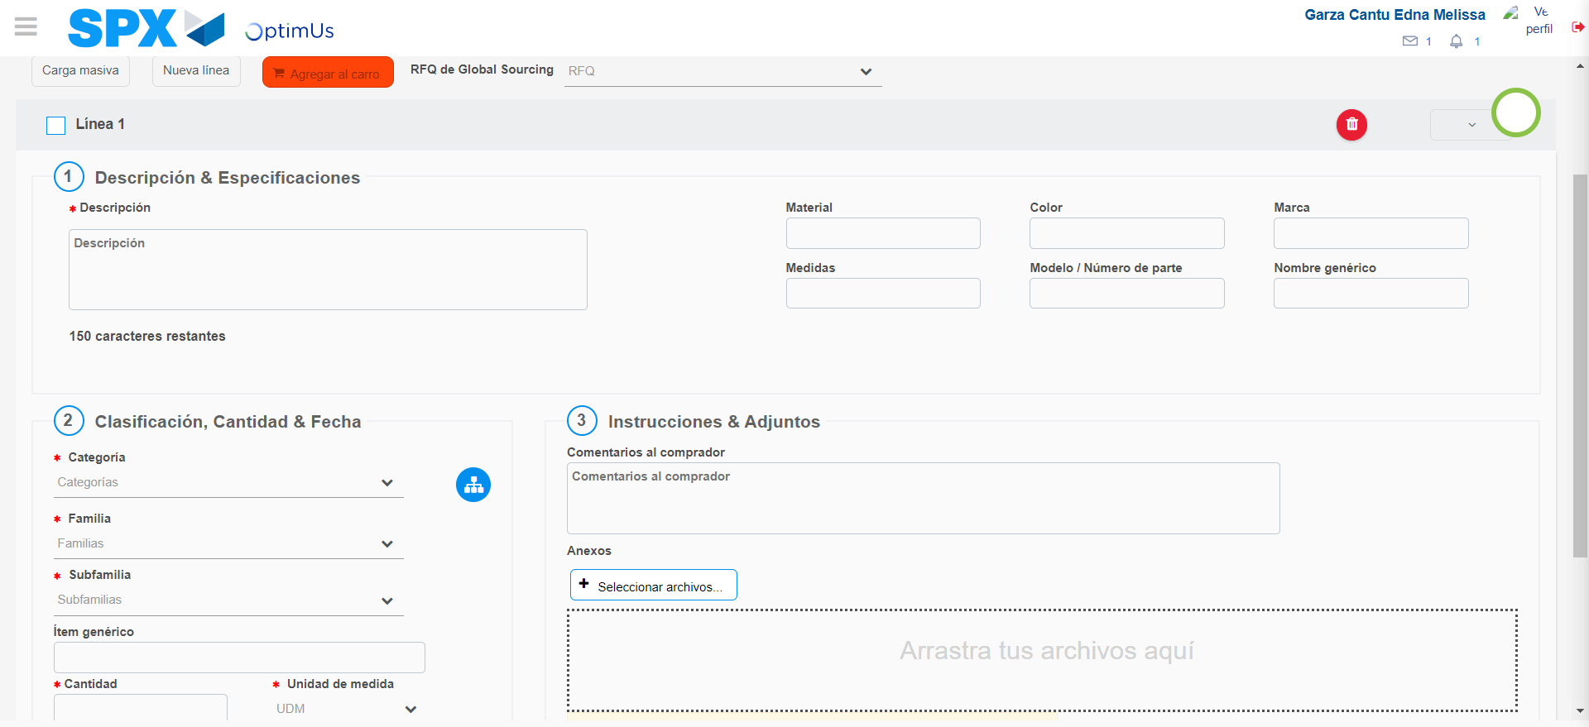Image file-name: QC_Testing-tc001_SPX_Dev5_Crear_Requisicion_Spot_Tipo_Cobro_CC-ene. 08 2024, 05 28 09 p. m.

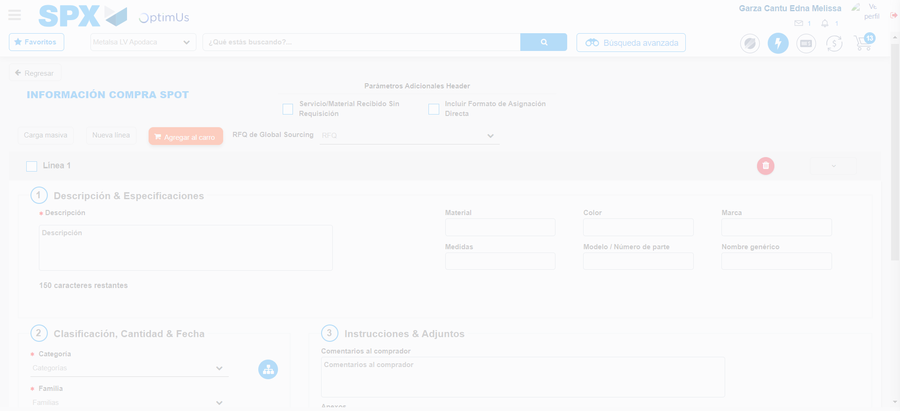Image file-name: QC_Testing-tc001_SPX_Dev5_Crear_Requisicion_Spot_Tipo_Cobro_CC-ene. 08 2024, 05 28 12 p. m.

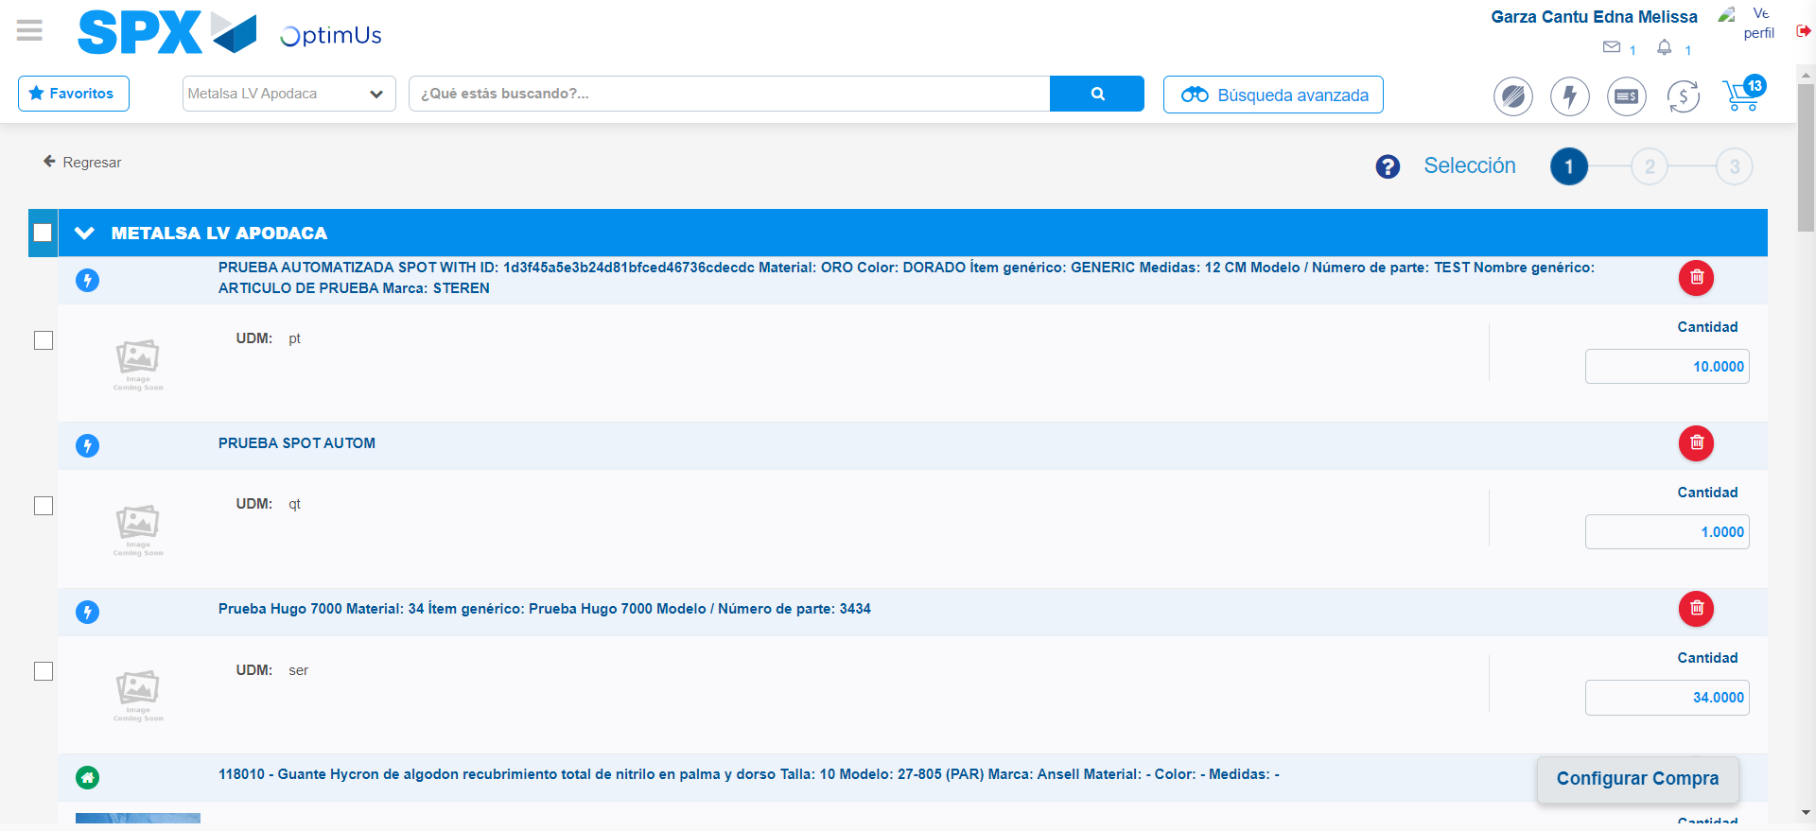Image file-name: QC_Testing-tc001_SPX_Dev5_Crear_Requisicion_Spot_Tipo_Cobro_CC-ene. 08 2024, 05 28 15 p. m.

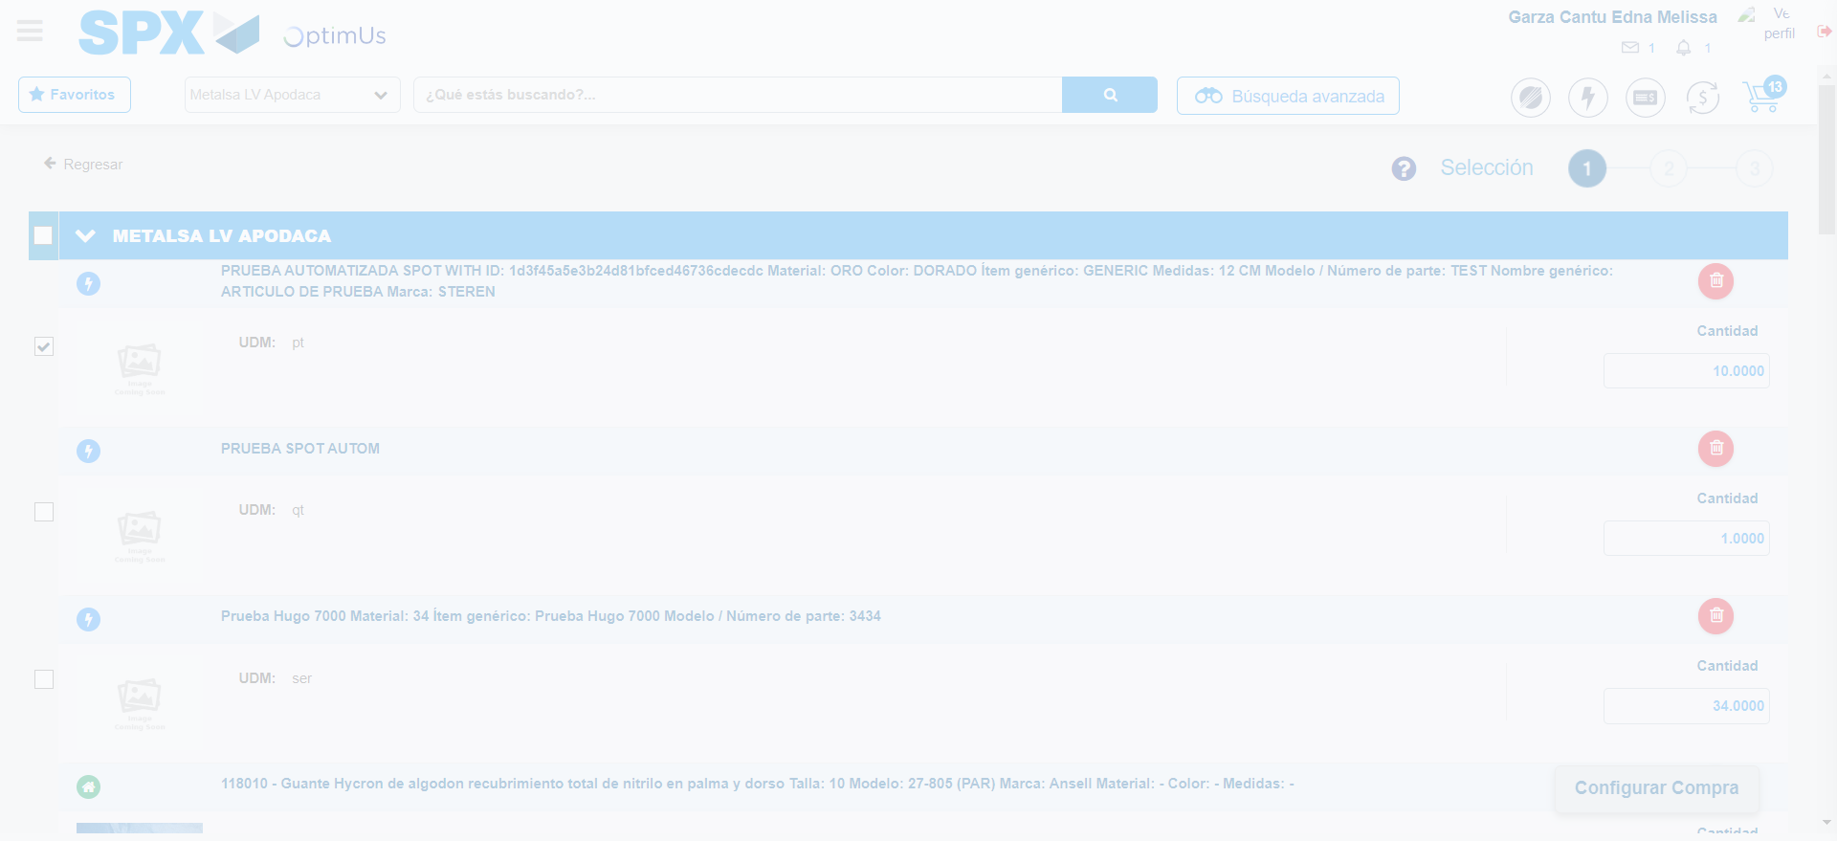Image file-name: QC_Testing-tc001_SPX_Dev5_Crear_Requisicion_Spot_Tipo_Cobro_CC-ene. 08 2024, 05 28 16 p. m.

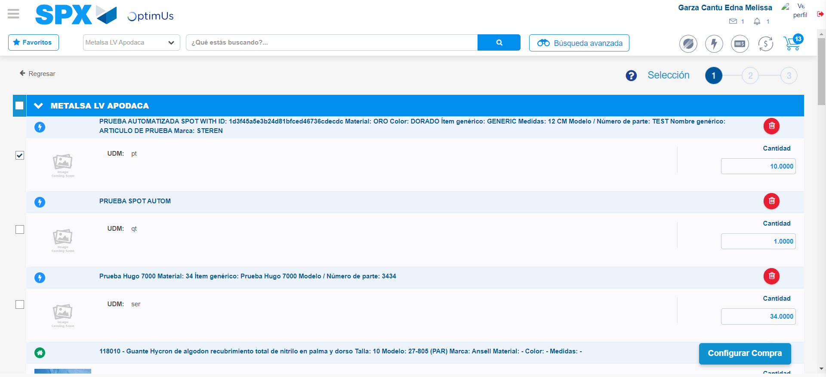Image file-name: QC_Testing-tc001_SPX_Dev5_Crear_Requisicion_Spot_Tipo_Cobro_CC-ene. 08 2024, 05 28 19 p. m.

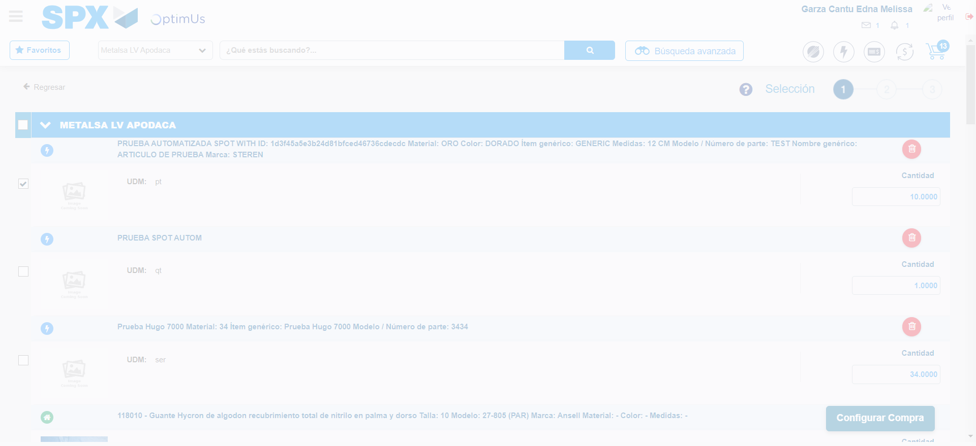Image file-name: QC_Testing-tc001_SPX_Dev5_Crear_Requisicion_Spot_Tipo_Cobro_CC-ene. 08 2024, 05 28 20 p. m.

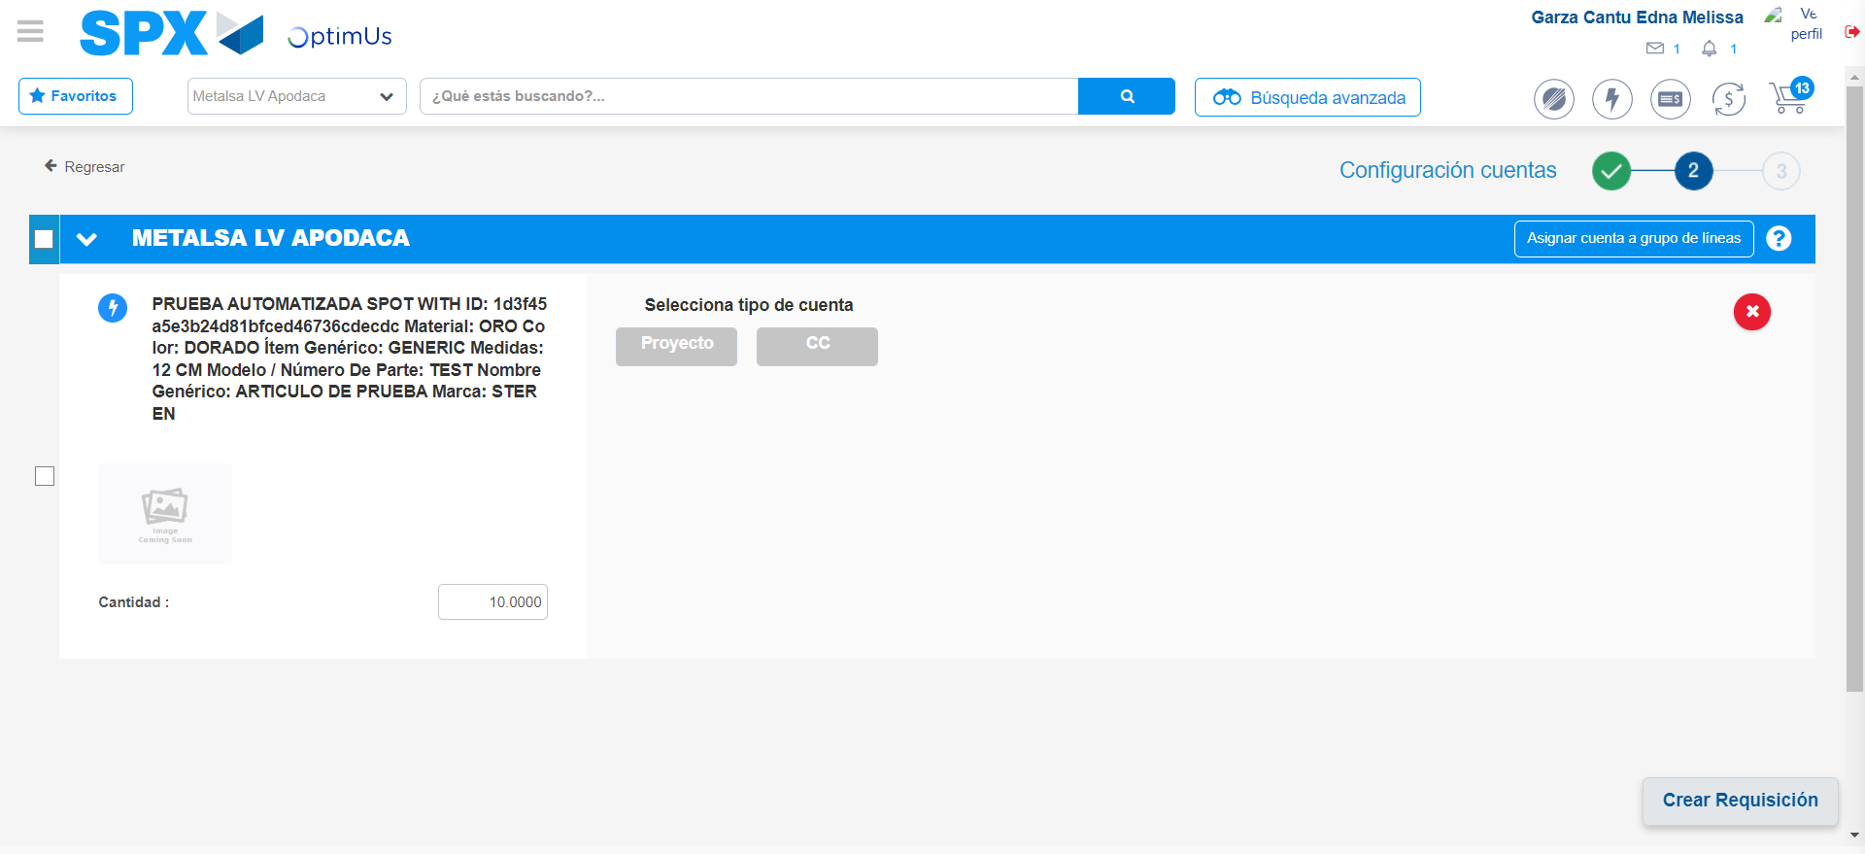Image file-name: QC_Testing-tc001_SPX_Dev5_Crear_Requisicion_Spot_Tipo_Cobro_CC-ene. 08 2024, 05 28 23 p. m.

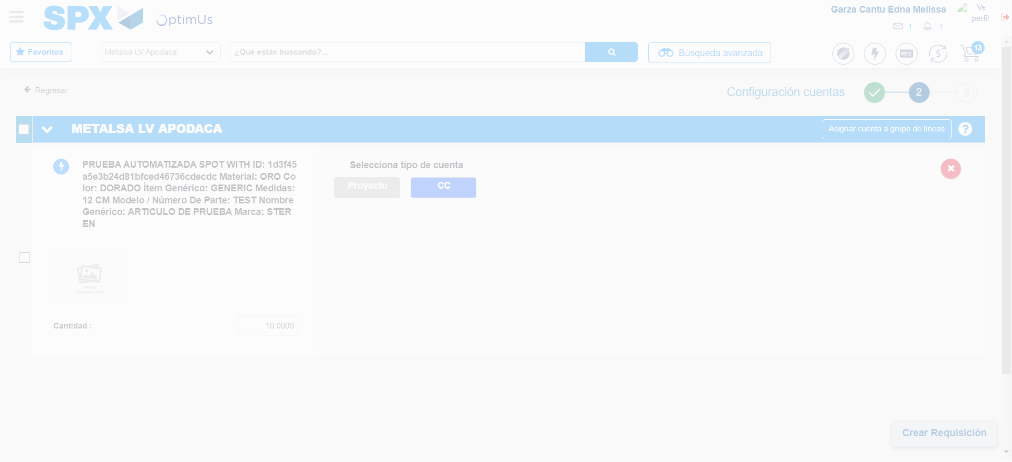Image file-name: QC_Testing-tc001_SPX_Dev5_Crear_Requisicion_Spot_Tipo_Cobro_CC-ene. 08 2024, 05 28 24 p. m.

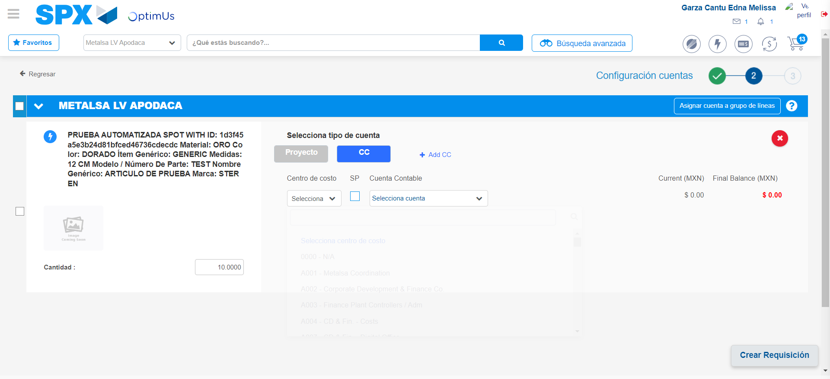Image file-name: QC_Testing-tc001_SPX_Dev5_Crear_Requisicion_Spot_Tipo_Cobro_CC-ene. 08 2024, 05 28 27 p. m.

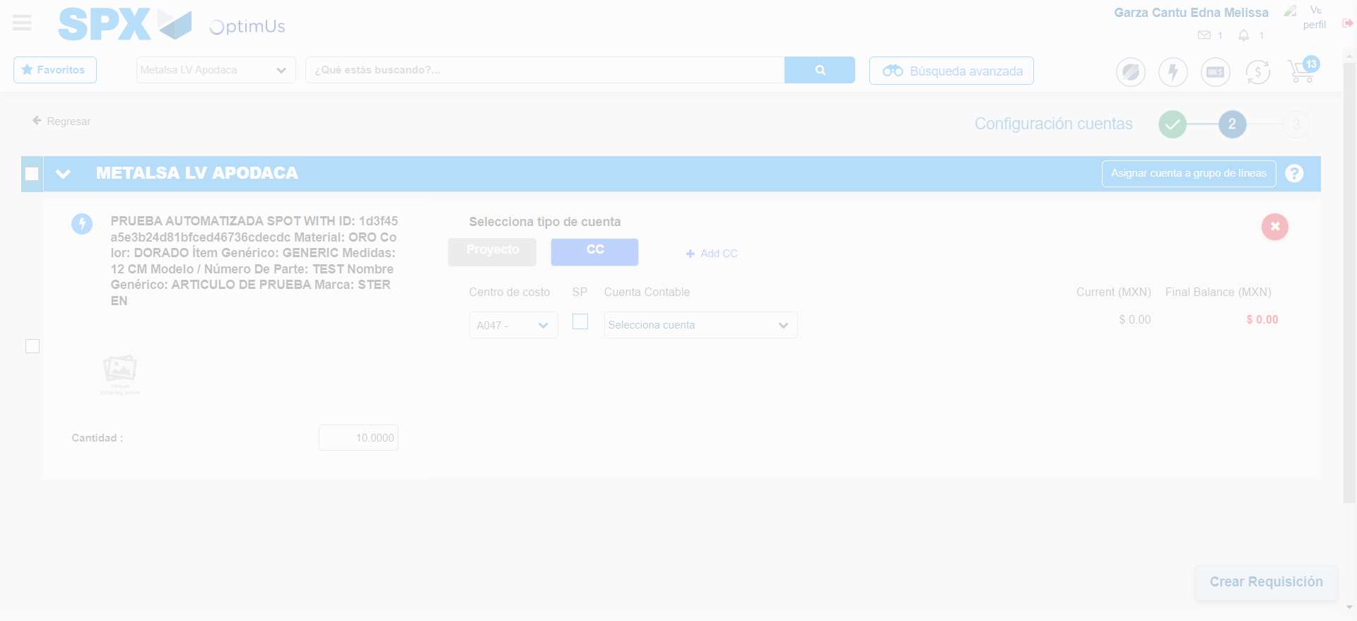Image file-name: QC_Testing-tc001_SPX_Dev5_Crear_Requisicion_Spot_Tipo_Cobro_CC-ene. 08 2024, 05 28 28 p. m.

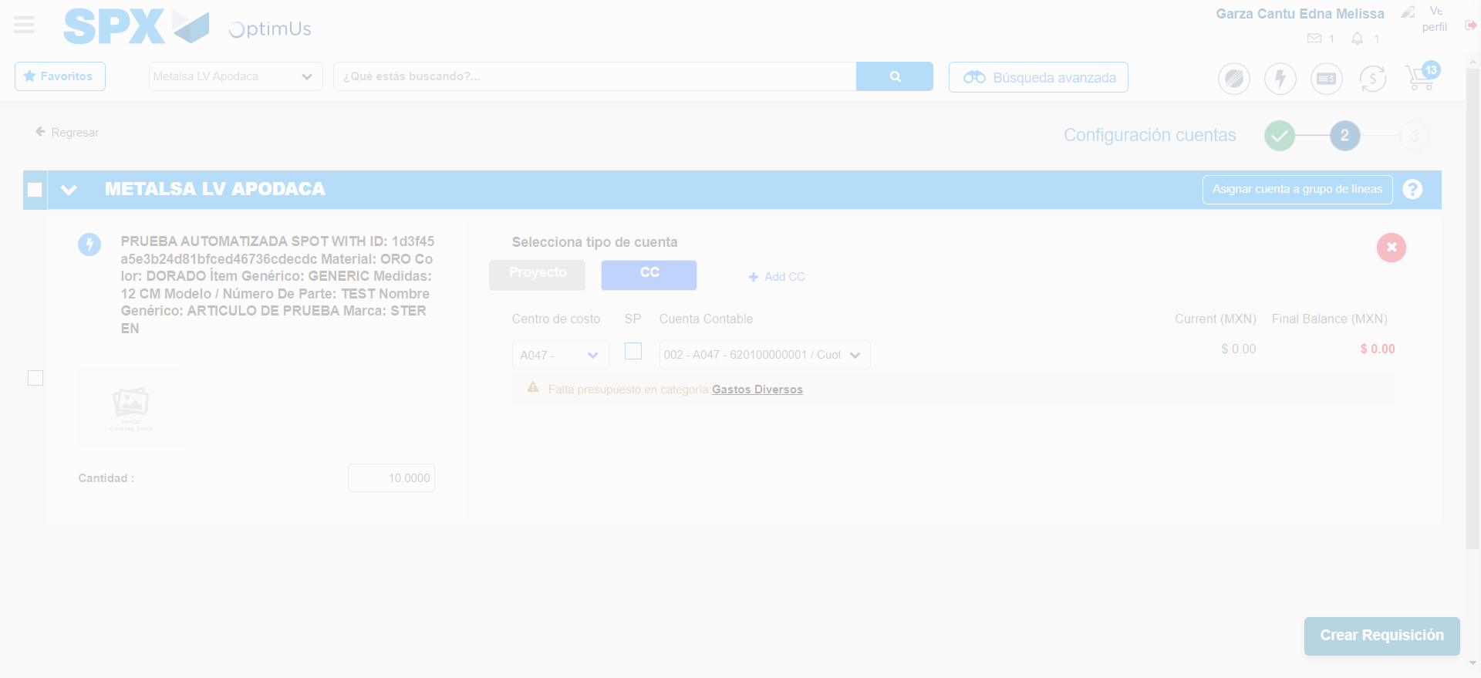Image file-name: QC_Testing-tc001_SPX_Dev5_Crear_Requisicion_Spot_Tipo_Cobro_CC-ene. 08 2024, 05 28 34 p. m.

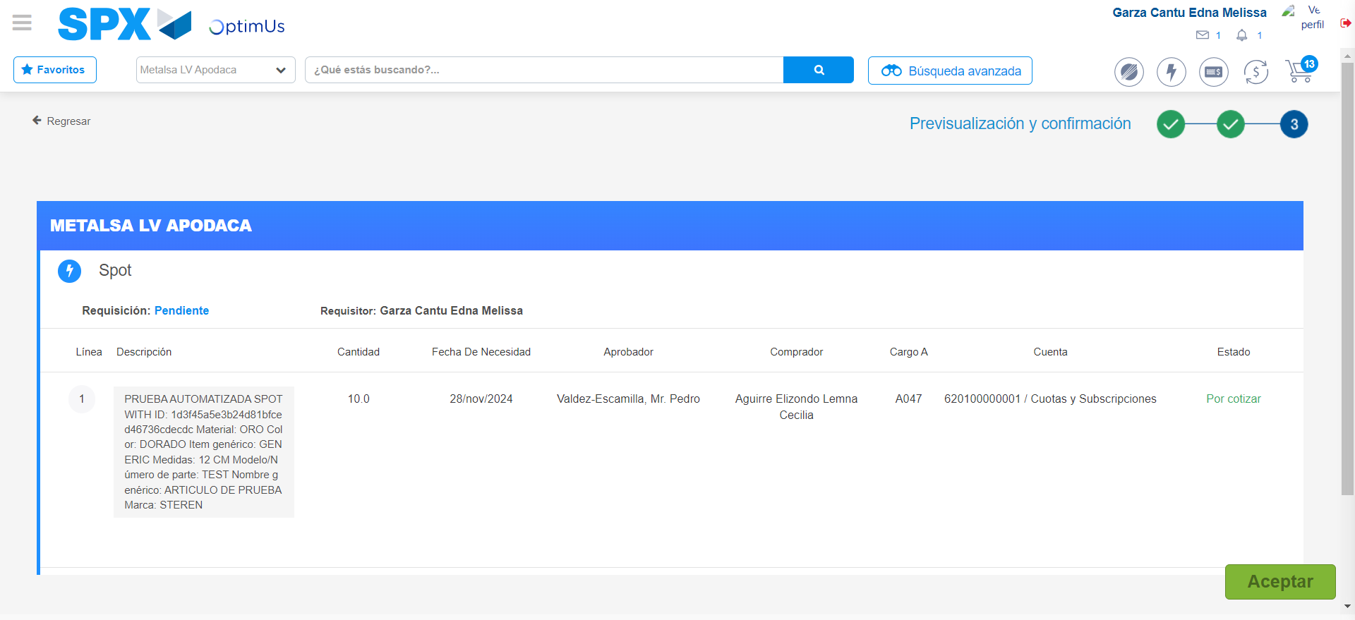Image file-name: QC_Testing-tc001_SPX_Dev5_Crear_Requisicion_Spot_Tipo_Cobro_CC-ene. 08 2024, 05 28 38 p. m.

Image file-name: QC_Testing-tc001_SPX_Dev5_Crear_Requisicion_Spot_Tipo_Cobro_CC-ene. 08 2024, 05 28 41 p. m.

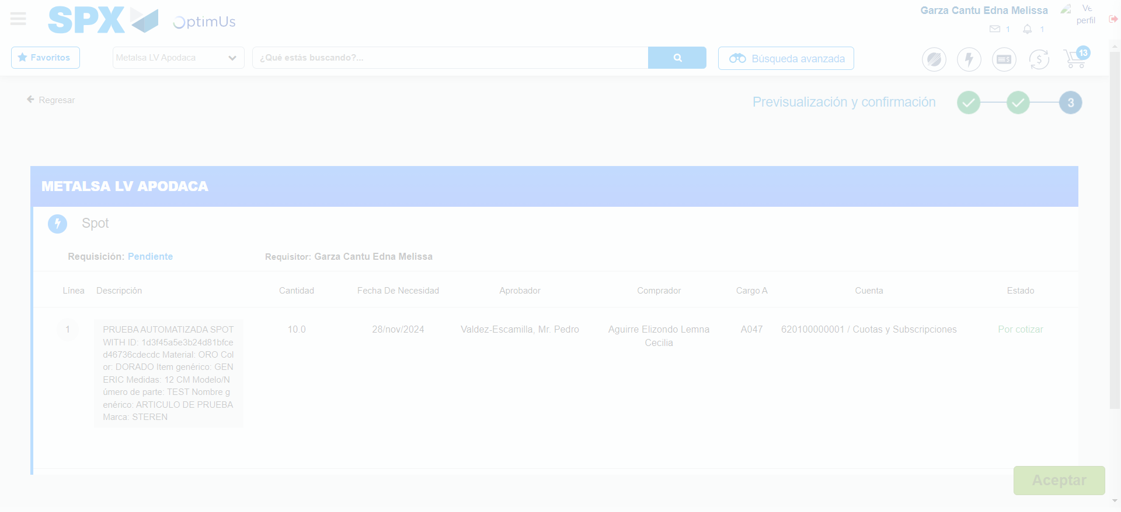Image file-name: QC_Testing-tc001_SPX_Dev5_Crear_Requisicion_Spot_Tipo_Cobro_CC-ene. 08 2024, 05 28 42 p. m.

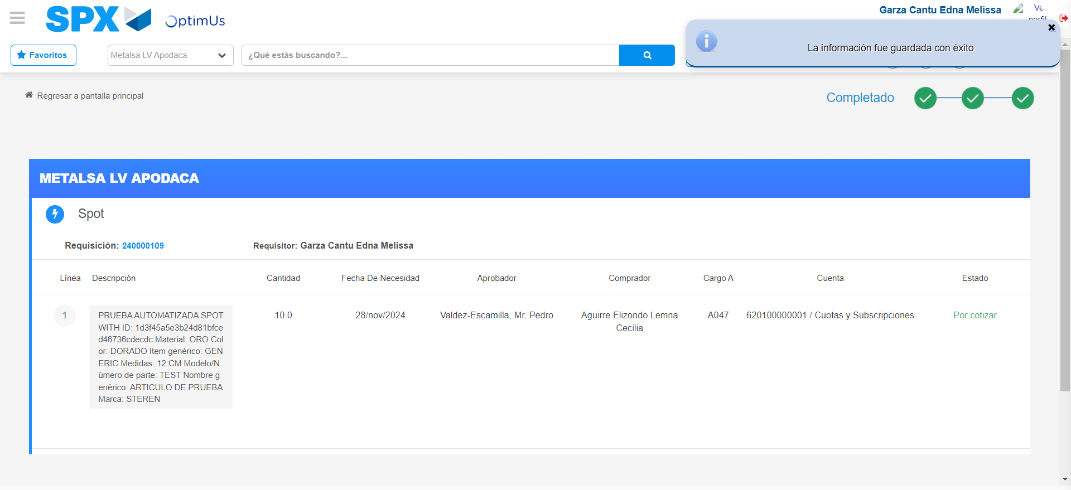Image file-name: QC_Testing-tc001_SPX_Dev5_Crear_Requisicion_Spot_Tipo_Cobro_CC-ene. 08 2024, 05 28 45 p. m.

